FIELD OFFICE VII

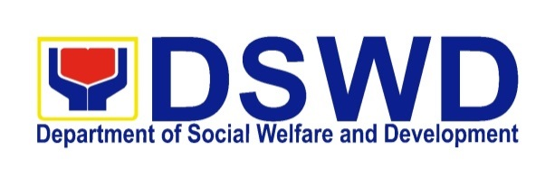
Invitation to Bid

Supply and Delivery of Toiletries for DSWD-NIR

DSWD7-PB-2016-47

- The Department of Social Welfare and Development, Field Office VII (DSWD-FO VII), through the authorized appropriations for Fiscal Year 2016 General Appropriations Act intends to apply the sum of One Million Three Hundred Sixty Two Thousand Pesos (₱1,362,000.00) being the Approved Budget for the Contract (ABC) to payments under the contract for Supply and Delivery of Toiletries for DSWD-NIR. Bids received in excess of the ABC shall be automatically rejected at bid opening.

- The DSWD-FO VII now invites bids for the said project. Bidders should have contracts, within three (3) years from the date of submission and receipt of bids, a single largest completed contract similar to the Project equivalent to at least 25% of the ABC which is at least ₱340,500,000.00. The description of an eligible bidder is contained in the Bidding Documents, particularly, in Section II. Instructions to Bidders.

- Bidding will be conducted through open competitive bidding procedures using a non-discretionary “pass/fail” criterion as specified in the Implementing Rules and Regulations (IRR) of Republic Act (RA) 9184, otherwise known as the “Government Procurement Reform Act”.

Bidding is restricted to Filipino citizens/sole proprietorships, partnerships, or organizations with at least sixty percent (60%) interest or outstanding capital stock belonging to citizens of the Philippines, and to citizens or organizations of a country the laws or regulations of which grant similar rights or privileges to Filipino citizens, pursuant to RA 5183 and subject to Commonwealth Act 138.

- Interested bidders may obtain further information from the BAC Secretariat and inspect the Bidding Documents at the address given below during office hours.

A complete set of Bidding Documents may be purchased by interested Bidders starting September 21, 2016 from the address below and upon payment of a nonrefundable fee for the Bidding Documents in the amount of Five Thousand Pesos (₱5,000.00).

It may also be downloaded free of charge from the website of the Philippine Government Electronic Procurement System (PhilGEPS) and the website of the Procuring Entity, provided that Bidders shall pay the nonrefundable fee for the Bidding Documents not later than the submission of their bids.

The Bids and Awards and Committee (BAC) will hold a Pre-Bid Conference on September 29, 2016, 3:00 PM at DSWD Conference Room of the procuring entity which shall be open only to all interested parties who have purchased the Bidding Documents.

- Bids must be delivered to the BAC Secretariat Office of the procuring entity on or before October 11, 2016, 3:00 PM. All Bids must be accompanied by a bid security in any of the acceptable forms and in the amount stated in ITB Clause 18.

Bid opening shall be on October 11, 2016, 3:15 PM at DSWD Conference Room of the procuring entity. Bids will be opened in the presence of the Bidders’ representatives who choose to attend at the address below. Late bids shall not be accepted.

- Participating bidders shall submit two (2) copies of their duly accomplished eligibility requirement, technical and financial proposals.

- The DSWD-FO VII reserves the right to accept or reject any bid, to annul the bidding process, and to reject all bids at any time prior to contract award, without thereby incurring any liability to the affected bidder or bidders.

- For further information, please refer to:

MS. JOSEPHINE C. BELOTINDOS
Head, BAC Secretariat
DSWD – F.O. VII
M.J. Cuenco corner Gen. Maxilom Avenue, Cebu City
Tel. Nos. (032) 412-9908; 233-8785 local 132 or 127
Email Add: bacsec.fo7@gmail.com
Website: www.fo7.dswd.gov.ph

(Sgd.) GRACE Q. SUBONG
Chairperson, Bids & Awards Committee

